Lab 12: Final Project
Pulse Oximeter

Kevin Chau
23816929
Lab Partner: Zander Giuffrida
Physics 111, Spring 2015

Introduction

Pulse oximetry is the measurement of blood oxygen saturation using an LED transmitter to shine optical and infra-red light through blood vessels. When the heart pumps oxygenated blood into peripheral arteries and veins, a light signal shone through these vessels will modulate at the same rate as a heartbeat, due to the changing absorption of light in hemoglobin as new cells are oxygenated. Since this technique for measuring oxygen saturation relies only on light, it is relatively non-invasive and can be used for a variety of instruments which need to measure heart rate and oxygen level. Such devices are useful in monitoring and treating heart and lung health, as well as measuring proper blood flow and cardio-vascular health in peripheral vessels.

In this project, we implement a simple pulse oximeter with analog circuitry and LabVIEW programming. The design entails building a photo transmitter and receiver, and also requires knowledge of signal processing in order to extract the relevant heartbeat pulses and amplitudes. Using this oximeter design, we were able to extract an accurate reading for heartbeat frequency and oxygen saturation.

Background

Our design is based on a paper in the IEEE Instrumentation and Measurement Magazine [2] which outlines the theory of blood pulse oximetry. Here we provide a brief overview of the physical process and mechanism of non-invasive light oximetry.
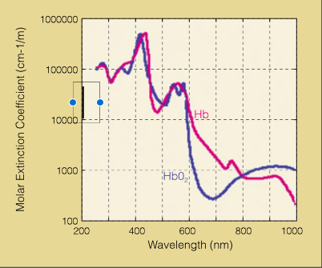

Figure 1: Hb and HbO2 Absorption Spectra

Oxygen saturation is defined as the ratio of oxygenated hemoglobin concentration [HbO2] to that of the total hemoglobin (deoxygenated and oxygenated) [HbO2 + Hb]:
SO2 = [HbO2]/[HbO2+Hb]
SO2 varies between arteries and veins, so we denote each saturation level by SaO2 and SvO2. For a healthy individual, normal SaO2 levels are between 95%-99%, and should be relatively consistent if the subject stays in the same environment during the period of measurement.

Oxygenated and deoxygenated hemoglobin have slightly different light absorption spectra, but we can leverage this fact to make optical measurements to calculate O2 levels in the blood. The absorption of red and infrared light is low compared to other wavelengths found in normal optical white light, so these frequencies are ideal for accurate measurements of light transmission through the blood. Since we expect the oximeter to be making measurements in a well-lit room, choosing red and IR light sources for the transmitter will greatly reduce extra noise from ambient light sources. Relative concentrations of hemoglobin affect the value of absorption constants, thus we expect a heartbeat to modulate the amplitude of transmitted light signals. A graph of absorption by wavelength of oxygenated and deoxygenated hemoglobin is shown in Figure 1.

In particular if we use two light LEDs with close wavelengths we should only need to take into account some calibration constants to get a proper calculation of oxygen levels once a heartbeat signal has been detected. In order to acquire the heartbeat signal itself from the modulated light we will need a technique called photoplethysmography (PPG), which is the measurement of light absorption changes due to changes in blood value which is normal in the cardiac cycle. By tracking these changes in absorption, we should see normal heartbeat characteristics in our LabVIEW program which correspond to volume changes systole and diastole. A typical PPG signal looks like the following:
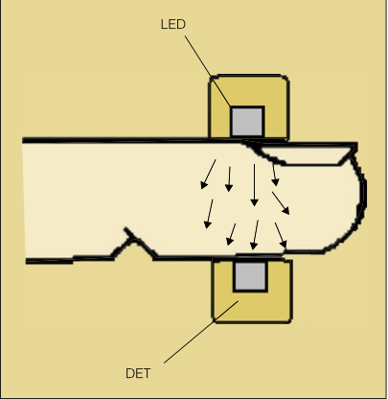
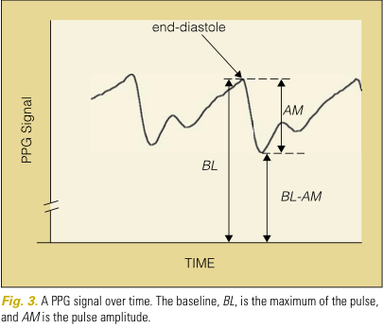

Figure 2a: A PPG signal—Systole and Diastole in a Heartbeat; 2b: LED and Detector Configuration

Extracting this signal in labVIEW takes several signal processing sub-modules. We've outlined the process in the block diagrams in the Design section of this report, as well an in-depth in the explanation of the programming further in the document. Briefly, extracting the PPG signal involves separate detection of the modulated red and IR signals (either through filtering or separate detectors) which are driven at distinct and separate pulsing frequencies. Applying a Fast Fourier Transform on this signal results in a peak in the driving frequencies in the new domain; the amplitude of the signal content at the driving frequencies can be seen being modulated at the same rate as a heartbeat.

By tracking the change in amplitude of the LED driving frequencies over time, we can construct a heartbeat signal. Once a heartbeat has been extracted, arterial oxygen saturation can be calculated by by measuring the different points in the signal. The notation from the literation can be seen in Figure 2's PPG graph. The Baseline (BL) is defined to be the maximum of the signal. The minimum of the signal is denoted BL-AM, which gives us the amplitude (AM) of the signal. These values are easy enough to extract in LabVIEW, but a good sampling technique involves choosing an averaging window with set thresholds. This explained in detail in the summary of the software and LabVIEW design aspects

After measuring the amplitude AM and baseline BL of the pulse, we can calculate the relative maximal change of the PPG signal AM / BL, which does not depend on the intensity of light. For a given wavelength the value of AM/BL depends on three factors:

1. the maximal arterial blood volume increase during systole
2. the optical path-length in the tissue for that wavelength
3. the extinction coefficient of that wavelength in that increment of blood.

Returning to the issue of calibration, we minimize the dependence of AM and BL measurements on factors 1 and 2 by choosing two close wavelengths λ1 and λ2 for the two LEDs. We define R, the ratio of the factor AM/BL for each wavelength:

The extinction coefficient ε for a given wavelength is a physical, measured constant which depends on the hemoglobin's absorption of that wavelength. The extinction coefficient can be broken down into the oxygenated HbO2 dependence ε_{O} and the deoxygenated Hb dependence ε_{D}, yielding:
ε = εo SaO2 + εd (1−SaO2) = εd + SaO2 (εo − εd )
Using the fact that R is also the ratio of the extinction coefficients for two similar wavelengths, we solve for SaO2 to get:
where 1 and 2 denote λ1 and λ2
Design

Hardware: Circuits and Components

Schematics
The following diagrams shows the final schematics of the pulse oximeter. The first circuit (Fig 3) is a 555 timer based custom square wave generator. The second circuit (Fig 4) is a photodetector which is based on the phototransistor OP802SL. At a high-level view, the pulse oximeter is a two module design, composed of a dual LED emitter driven with the 555 square wave generators and a photodetector to amplify the light signal being modulated by the flow of blood. A simple clothespin splint can be used to to house the red and IR LEDs and the photo-sensitive element, which is well-suited for transmitting and receiving light through a finger or better yet blood vessels in the ear lobe. Good craftsmanship and wiring to the op-amps and generators is both ideal and necessary, as the signal to noise ratio of the photodetector is very dependent on the geometric configuration of the apparatus.

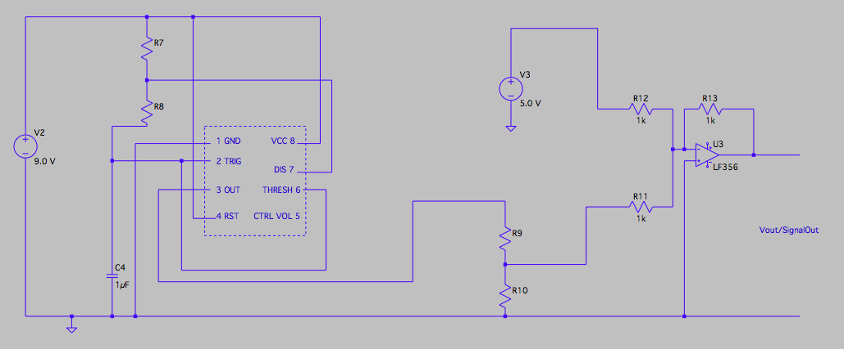
Figure 3: Square Wave Generator

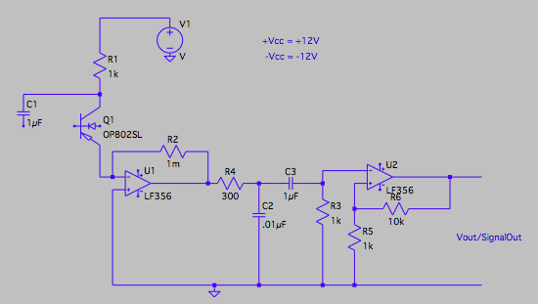
Figure 4: Photodetector
Square Wave Generator
The portable signal generator to drive the LEDs has a simple block diagram, consisting of the 555 timer, and a summing amplifier to add a DC offset to the square wave. We set up the voltage divider and 555 timers to produce a signal with a 5V DC component, while the AC component had an amplitude such that it was modulating the signal at 10-20%.
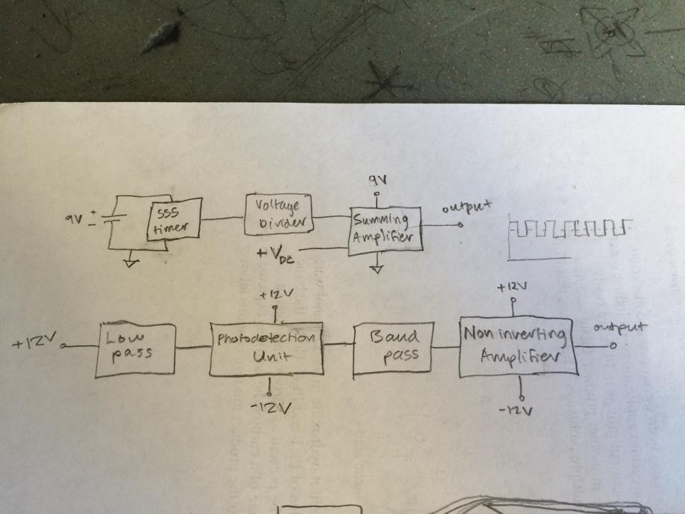

We found through some debugging that we could get a clearer signal powering the 555 timers with batteries rather than the power supplies. When we used the supplies, we often had to use decoupling capacitors to see a properly modulated square wave in the oscilloscope. For the sake of simplicity and keeping with the original portable design, we configured the summing amplifier and voltage divider to work with the 9V battery alongside the 555 timers.

We built two of these square wave generators—one for each LED. Of course, each generator needed to have distinct frequencies, otherwise sampling with our photodetector would yield less useful data. We built these generators before purchasing the LEDs, so we didn't know what wavelengths in the red and IR range we would be dealing with. We decided to produce square waves at 10kHz and 20kHz, and leave assigning the generators to their respective LED's for when we could test with the oscilloscope.

Summing Amplifier/ Modulator:
The following diagram is a standard inverting summing amplifier. It sums its input voltages according to the ratio of Rf to the input resistors. For our summing amplifiers, it sufficed to use 1 to 1 summing, so we chose Rf = R1 = R2 = 1kOhm. With this configuration, the summing amplifier directly added the 5V offset from the voltage divider to the signal from the 555 timer, without any extra weights. Since the summing amplifier is inverting, we used another op-amp at Vout to act as inverting buffer. The LEDs can be connected to the output of these buffers, which completes the design of our LED modulators.
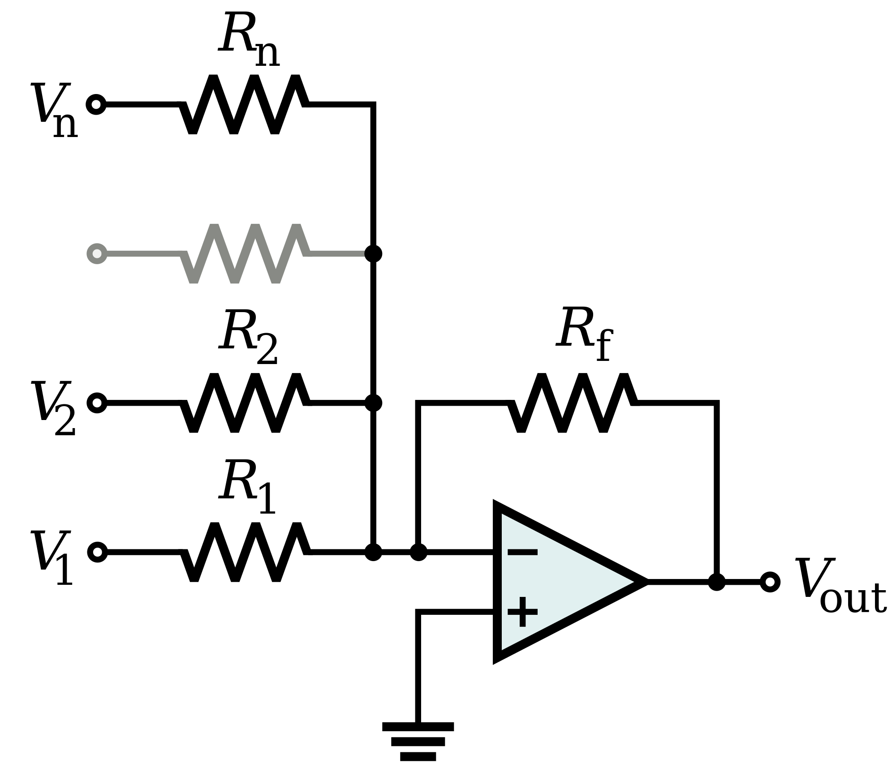

Figure 5: Summing Amplifier

Photodetector
A photodetector is a simple amplifying circuit with an output voltage dependent on input light intensity. Photodetector circuits can be constructed by using an op-amp to amplify the voltage of a light sensitive component, such as a photodiode, phototransistor, or photocell. In our design, we used the phototransistor component OP802SL. Its datasheet is readily available online, and its spectral response curve indicates that it is highly sensitive to IR and Red wavelengths, which makes it ideally suited for our purposes (especially since we will be shining these lights through an opaque finger!).
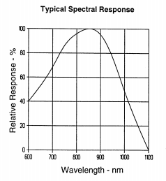

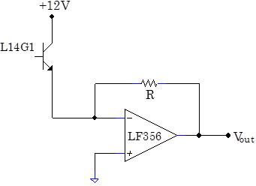

LED Wavelengths
With our photo-sensitive element decided on, we dialed in our LED wavelength values and set out to find the appropriate components. We settled on a standard red LED found in the lab room which is rated at 650-750nm (typical red light). For the IR light, we ordered some LEDs on the internet rated for 800nm-850nm. Since these matched the values in the research we did and aligned with the spectral response of the photodetector, we could now move on to the signal processing and programming portion of the design.

Waveform Generator- finding the right LED frequencies
At this point in building our circuit components we had begun testing the quality of the signals that we could detect with the phototransistor. The modulated signal from the 555 timer circuit proved difficult to detect through the phototransistor without significant noise. In the interest of time we decided to set aside our battery powered circuit designs based on the 555's, and instead we drove the LEDs with the wave generator until we could get a working oxygen and heartbeat reading. The driving frequencies remained at 10kHz and 20kHz. With the wave generators, we determined that signals were clearest in the oscilloscope when the RED LED was driven at 10kHz, and the IR LED was driven at 20kHz. We were able to detect clear square waves through our fingers.

The waveform generators typically produced at voltage of 5V for each of the LEDs. To avoid burning out the LEDs, we used resistors in series to reduce the current through the LED while maintaining the brightness. In some cases, we needed to reduce the power of the red LED down to 2 or 3V so that we could see both red and IR pulses in the oscilloscope.

An interesting and puzzling phenomenon we stumbled upon during this phase of the project was that we could get the clearest signal when we used a capacitor between the photodetector's op-amp MINUS input and ground. However, this capacitor would charge up and as a result we would see an upward drifting heartbeat signal in LabVIEW (more on this later). While removing the capacitor made oscilloscope readings almost impossible sometimes, this removed the capacitive charging we saw in LabVIEW, and otherwise did not affect the performance of the detector.

Circuit Filters
There were a lot of issues with electrical noise, even after using a significant number of decoupling capacitors in our design. Thus we added a low pass filter on the phototransistor before the first op-amp to remove high frequency noise from the power supply. Furthermore, we often saw a 100kHz noise signal which proved very hard to remove. The best solution for this was a bandpass filter, that not only
attenuated frequencies well above the driving frequencies of the LEDs, but also the normal 60Hz ambient electrical noise often seen in our lab circuits. For some reason, the high frequency noise was related to the 60Hz noise, and would only be removed with a bandpass to isolate our driving frequencies.

High gain amplifier
Since the signals coming through our fingers were significantly smaller than signals passed through non-opaque materials, we needed one more amplifier to increase the signal strength and reduce the noise ratio. We chose a non-inverting amplifier with a gain of 10.

Finger Splint and LED Positioning
For the physical interface of our detector and emitter circuit, we used a clothespin to house the LEDs and phototransistor. The red and IR lights were positioned with a separating angle of 120 degrees, with the photodetector bisecting this angle. Here is a picture of our finger splint set up, designed to quickly position the sensor around a finger:
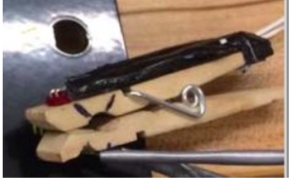

The splint was useful for reducing the dependency on geometry of our signal clarity, however we still found that the circuit was fairly sensitive to movement, so the user had to stay almost completely motionless to get a consistent signal.

Block Diagram
Before we explain the software components, we provide a high level view of our entire design.
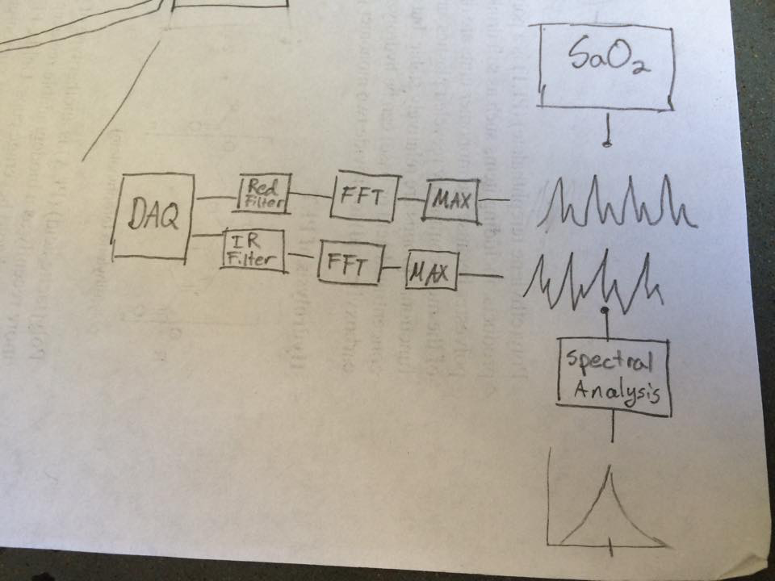
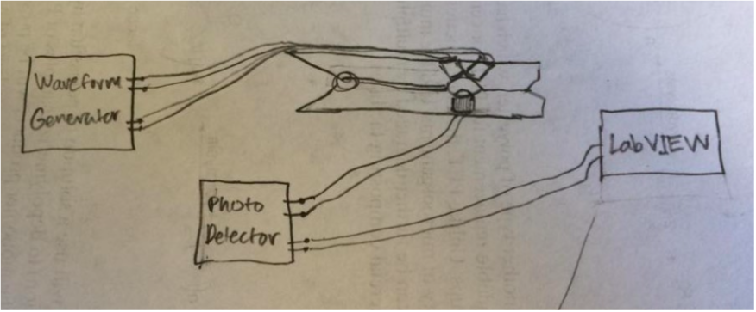

Software: LabVIEW Data Acquisition and Digital Signal Processing
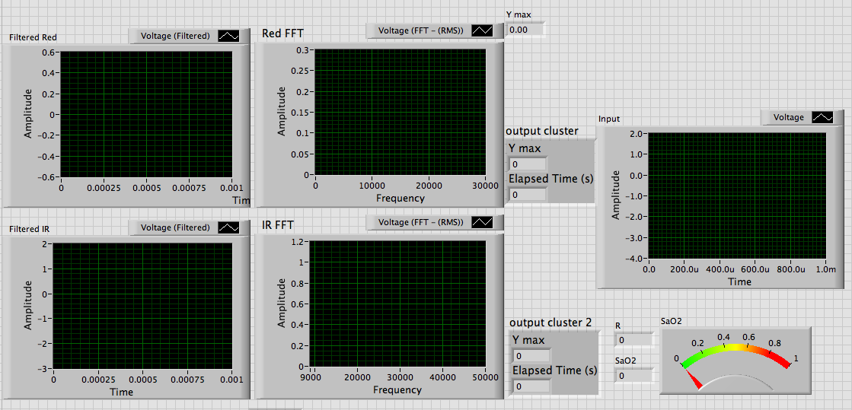
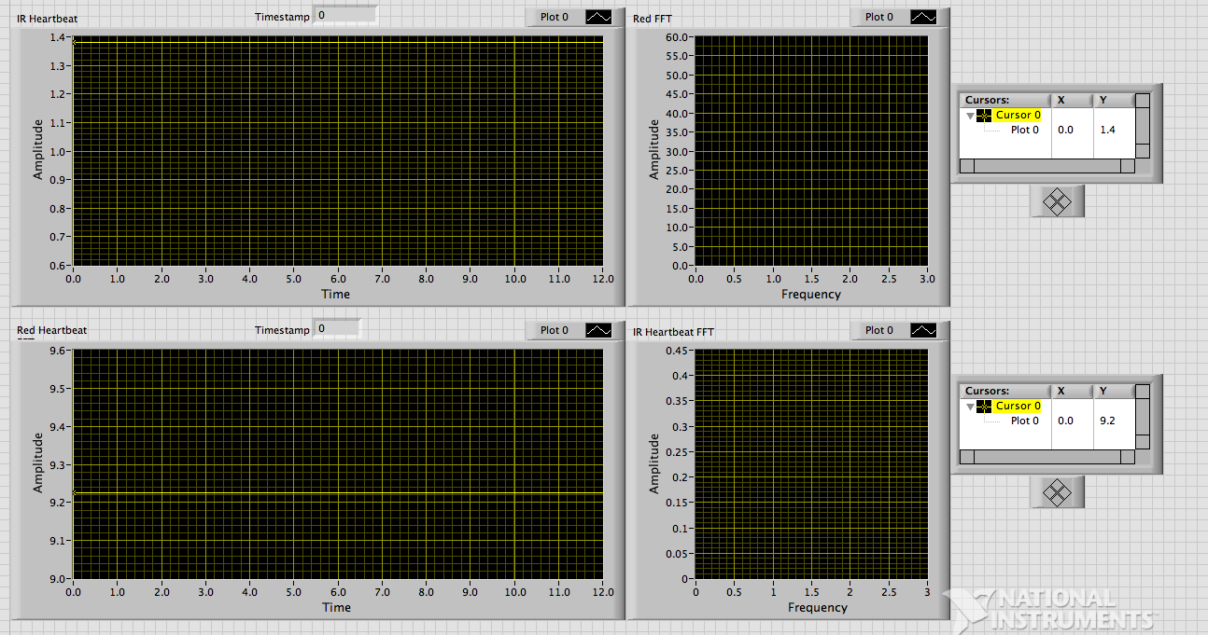
Front Panel Interface for our LabVIEW program

Structure and Data Acquisition
The LabVIEW program is based on a DAQ Assistant that continuously records from the output of the photo-detector circuit (more specifically, the output of the non-inverting amplifier). The VI records 20k samples of the voltage signal at a sampling rate of 100kHz. Since the DAQ takes continuous measurement, we had to keep in mind that LabVIEW structures our program as an infinite for loop that only stops when we tell it to. For this reason, we needed to use shift registers when building our data arrays.

Filtering and Signal Splitting
After acquiring raw signal data from the photo detector, we need to separate the red and IR frequencies using software. This can be done easily with some good filtering. The signal from the DAQ is fed into a 3rd order butterworth filter with cutoffs at 5kHz and 5kHz, which extracts the RED LED's 10kHz pulse. Similarly, we used another bandpass filter with cutoffs at 15kHz and 25kHz to extract the 20kHz IR signal. This can be seen in the top left portion of the following LabVIEW block diagram of our program oximeter.vi:

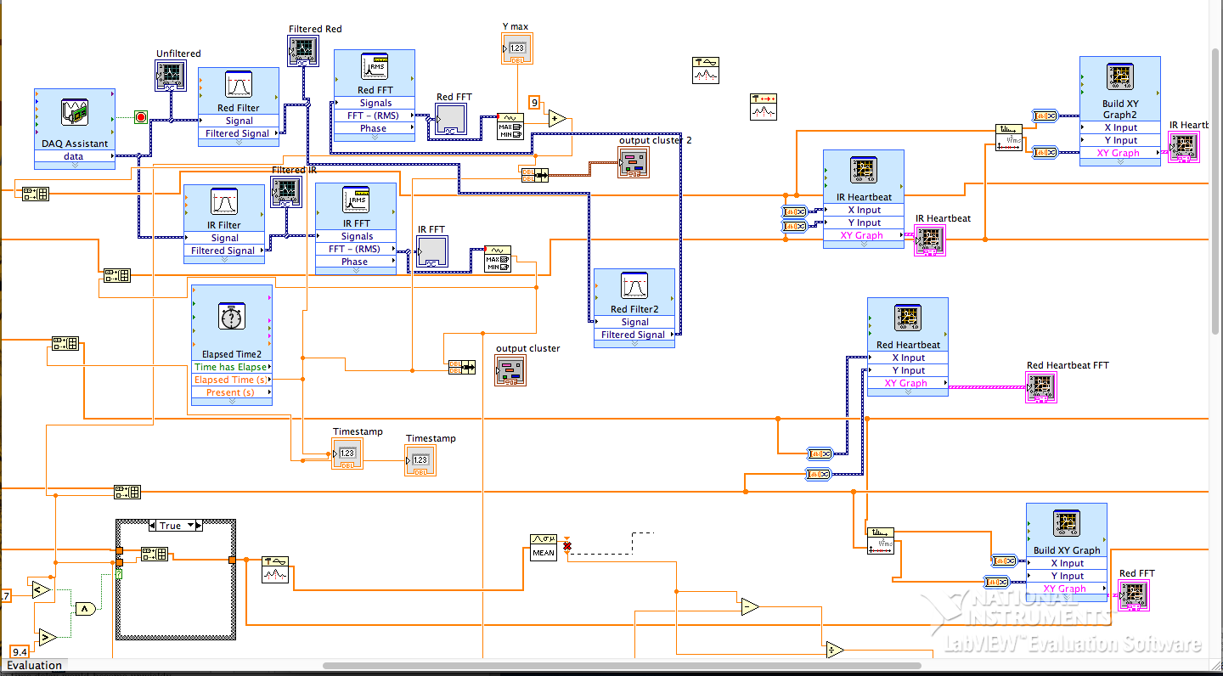

Fast Fourier Transformation
Returning to our original goal, we need to track the change in amplitude in the spectral content of our modulated LEDs in order to extract a heartbeat signal. To do this, we fast Fourier transform the red and IR filtered signals separately. This produces two Fourier domain graphs (labeled RED FFT and IR FFT in the front panel), with peaks at the driving frequencies 10kHz and 20kHz. Preliminary graphs of the Fourier-transformed PPG signal showed the amplitude moving up and down at a rate comparable to a heartbeat. Suspecting that what we saw was our actual heartbeat, we moved on to building a real-time graph of the signal.

Heartbeat Interpolation
At this stage we are trying to have a real-time readout of our heartbeat, similar to an EKG, without measuring amplitudes to make the oxygen measurements. In order to do so, we used the vi function Waveform MIN MAX which continuously record peaks in the FFT graphs that we produced in the previous step. We bundle this periodic MAX measurements with a timestamp generated in LabVIEW, and append these data points to a dynamic array that is being build every iteration of the DAQ loop using shift registers. This 2D time-amplitude array can be displayed as an XY graph using dynamic data conversion. As a result, we get a heartbeat graph, corresponding to the bottom window of the front panel image, that shows a heartbeat in real time. In order to confirm that we got a heartbeat, we used spectral measurements (just another FFT) again on this signal to verify that we were getting a heartbeat frequency around 1 to 1.2 Hz (60 to 70 beats per minute).

Amplitude Measurement/Sampling
Once a heartbeat is extracted, oxygen levels can be read by making measurements on the RED heartbeat amplitudes and IR heartbeat amplitudes. For reference, we bring back the AM/BL diagram presented in the introduction:

Our labVIEW mechanism for extracting values for BL and BL-AM are fairly straightforward. After enough heartbeats have been recorded, we take the average value of peaks to estimate BL and the average value of troughs to estimate BL-AM. We take their difference to calculate AM. We also used an extra case structure to exclude from our average peaks and troughs that were too high or too low, which represent erroneous and outlier data points which weaken our BL and AM measurements. In this way, our program ignored random movements in the user or charging/discharging signals from inserting and removing and finger from the splint.

SaO2 Measurement and Calibration
Since we have amplitude measurements on both our Red and IR heartbeat signals, we can apply the SaO2 formula if we properly calibrate our program. The use of two LEDs similar in wavelength should reduce the need for extensive calibration in the measurement of arterial oxygen saturation. If the optical red and infra-red wavelengths of the LED are known precisely, then we can just look up values for extinction coefficients in the references cited and plug in our AM and BL measurements into:

However, the wavelengths of our LEDs were not precisely specified, so we had to try many different combinations of values within the range of the LED specifications before we got reasonable readings. We wrote a quick python script to quickly test out reasonable values of LED parameters and extinction coefficients. We reasonably settled upon the values of 660nm for the RED, and 800nm for the IR, which were in appropriate ranges. We found with these chosen values of extinction coefficients, the SAO2 formula was reasonable for the type of AM and BL measurements that we were getting.

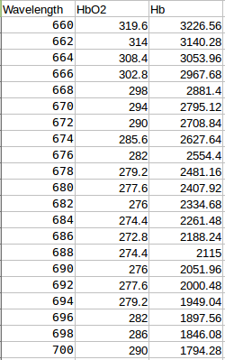
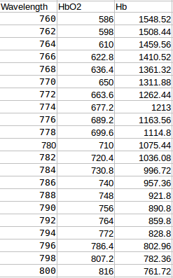

Results
After a reasonable amount of time spent calibrating and testing, in our final iteration of our design we actually achieved realistic results. Not surprisingly, our first oxygen reading was 94.8%. When we tested out the reader on other subjects, we found anything from 89% to 99%. More interesting were our results for the reading of heartbeat frequency. In the end we were able to read a heartbeat frequency of around 60BPM to 70BPM. On the spectral analysis graph, this was represented as a peak from 1Hz to 1.2Hz, and was slightly different for different subjects. Although our oxygen reading was not completely accurate, it was still reasonable, and our design was a successful prototype overall.

Problems and Solutions
Some of these issues have already been touched on in the report; for clarity, we reiterate some of the finer points of the debugging problems which were difficult or complicated to solve.

Waveform generator noise: The dominant noise in the generator was 100kHz noise originating from the power supply. To remove this noise, we used separate power supplies for the 555 timers and op-amps (9V batteries) along with decoupling capacitors across the supplies. Another setback of our waveform generator was that it was difficult to change the output frequencies and amplitudes on the fly. Furthermore, it was difficult to set the 555 timer parameters for the exact waveform shape (pulse width, duty cycle, etc). When we originally designed the timer, we used a 555 timer circuit calculator (which can be found on the internet) to quickly generate the components needed to produce the 10kHz and 20kHz signal. A potentiometer can be used in place of one of the resistors to have control of the frequency of the timers, if desirable. In the end, it was easier to debug our LabVIEW program with the stock waveform generators. However, using our own waveform generator would provide more mobility if we wished to make a portable oximeter. For more details about the portable oximeter see the conclusion.
Sampling rate: Originally we had the sampling rate too low, and the number of samples to high, for our DAQ Assistant. This caused an erroneous heartbeat signal at 1.5Hz to appear when we took the FFT of our heartbeat. We were able to identify this error by comparing it with our actual heartbeats (which were around 70bpm). We also realized this was not a relative error, since when we increased our heartbeat through physical activity, there was no noticeable shift in the frequency of the signal. By changing the sampling rate and number of samples of the DAQ, and modifying the wiring within LabVIEW, we were able to remove this faulty signal.
Uneven sampling: Another setback with the LabVIEW program occurred with the timing of measuring the peaks in the FFT to extract the heartbeat signal. The intervals between timestamps in our 2D array were uneven, so we needed the labview module Unevenly Sampled Signal Spectrum to extract a proper FFT of the heartbeat. Without this extra detail, the FFT frequencies were all halved.
Calibration: As discussed previously, our calibration was not extremely robust or scientific. While it was completely necessary that we made such calibrations since our LED wavelengths were not specific, we would need quite a bit more time and test subject in order to fully calibrate our sensors for a more permanent design.
Conclusion
In the end, this project demonstrated that just a few simple op-amp circuits, LEDs, and a phototransistor can be used to acquire a reasonable heartbeat signal. With proper signal processing and calibration, this pulse oximeter design also proved useful for measuring an actual heartbeat frequency (roughly 60-70BPM, or 1-1.2Hz), as well as an estimate of blood SaO2 to a reasonable degree (between 94% and 100%). Getting these results took more debugging time than actual circuit planning, although this was not unexpected. Throughout the final project, our debugging skills greatly improved, as did our LabVIEW skills and understanding of how labVIEW can process signals acquired in realtime. In hindsight it may have been better to start with the signal generators and then fine-tune our 555 wave generators, and I plan to do so in my next iteration of this design. However, there is room for many improvements to our design and I leave this project not before deeply considering several modifications and future plans.

In order to improve the signal to noise ratio of our photodetector, we would need to test a larger spectrum of light wavelengths to find which frequencies give an optimal efficiency. Furthermore, we would need to precisely measure the wavelength of the LEDs that we used if we wanted to fine-tune our SaO2 equation. Similarly, it would be beneficial for further studies into this project if the absorption spectrum of the photodiode itself were taken into account; perhaps using two separate detectors which were optimized for the LED wavelength choices. As a final note for the transmitter design, it would have been nicer to have a more permanent or structurally robust finger splint which was not greatly affected by small movements. We found that there were far too many noise issues related to the geometry of the LEDs with respect to the detector and finger placement.

Our plans at the beginning of the project originally included a design for a portable, battery-powered solution that could be easily reproducible and scaled for production. Any practical mobile solution would have to remove the LabVIEW component from the design. A suitable replacement would still require some type of processor—an Arduino or similar micro circuit could be implemented to handle the signal processing as well as providing a display/readout of measurements. The circuitry is relatively easy to solder onto a board (in fact, we had already started to before deciding to switch to the standard waveform generator and power supplies) and enclosure the size of an Altoid's tin would be sufficient. 9V batteries should work for powering the op-amps and the 555 timers, so a portable oximeter design is only a few modifications away from our original design.

References

[1] ”Physics 111 Instrumentation Laboratory.” Physics 111 Instrumentation Laboratory. 2014. http://instrumentationlab.berkeley.edu/.
[2] Nitzan, Meir, and Haim Taitelbaum. "The Measurement of Oxygen Saturation in Arterial and Venous Blood." IEEE Xplore. IEEE Instrumentation and Measurement Magazine, n.d. Web. 12 May 2015. <http://ieeexplore.ieee.org/stamp/stamp.jsp?tp=&arnumber=4534373>

[3] S. Prahl, The absorption spectra of the oxygenated and deoxygenated hemoglobin molecules. graph, [Online] http://omlc.ogi.edu/spectra/hemoglobin/index.html

[4] "Flashing LED Circuit." Flashing LED Circuit. 555 Timer Circuits, n.d. Web. 12 May 2015. <http://www.555-timer-circuits.com/flashing-led.html>.

